Deployment Document for Product Web Application

Insert Committee Name

January 01, 2020

## Purpose

The purpose of this document is to provide steps to build the code and execute the a web application code that imports a TSV file and displays all records from TSV, calculate revenue for each of the item and display Total revenue.

## Software Required

* Mysql
* MAMP – ( Software to run websites on local machines without requiring a webserver.It is a free software and can be downloaded from <https://www.mamp.info/en/downloads/>. I have used MAMP & MAMPPRO 4.1.1.
* Chrome or Firefox browser

## Deployment Instructions

* Unzip the “HCA-TSV.zip” provided and copy the folder on your computer. I have copied to D:\
* Install the MYSQL on your computer. I have installed My sql community server 8.0.18 from here <https://dev.mysql.com/downloads/mysql/>.
* Use the default configurations while installing mysql. It prompts for user name and password during the installation. I have used root as user name and root as password for this installation.
* Once the installation is complete, Launch MYSQL 8.0 command line client and run the commands from the product.sql file located in Import-TSV folder from the folder provided to create a database named HCA and create a “product” table
* Once the table is created, Open the MAMP software , navigate to Preferences under MAMP menu and click on ports. Use the following ports as displayed in the screen short below ( provided ports are not used by any other applications).

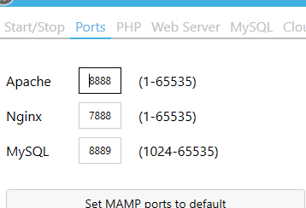

* Click on Webserver tab and select Apache and select the location of the directory where you have placed the unzip file. As mentioned earlier, i have placed it under D:\. Click Select once the location is mapped.

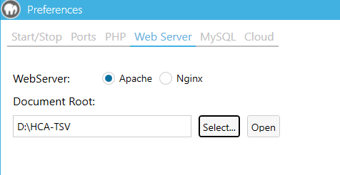

## Running the web application

* Copy the following link on your web browser. <http://localhost:8888/Import-TSV/>. You should the see the following.

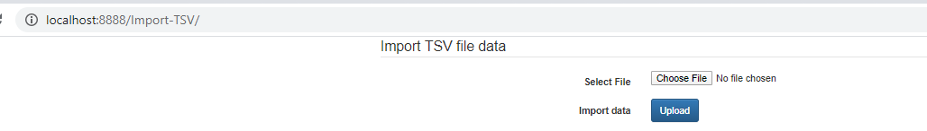

* Click on Choose File button, select the data.tsv provided, and click upload.
* You should see the following table that displays 100 records along with the revenue.

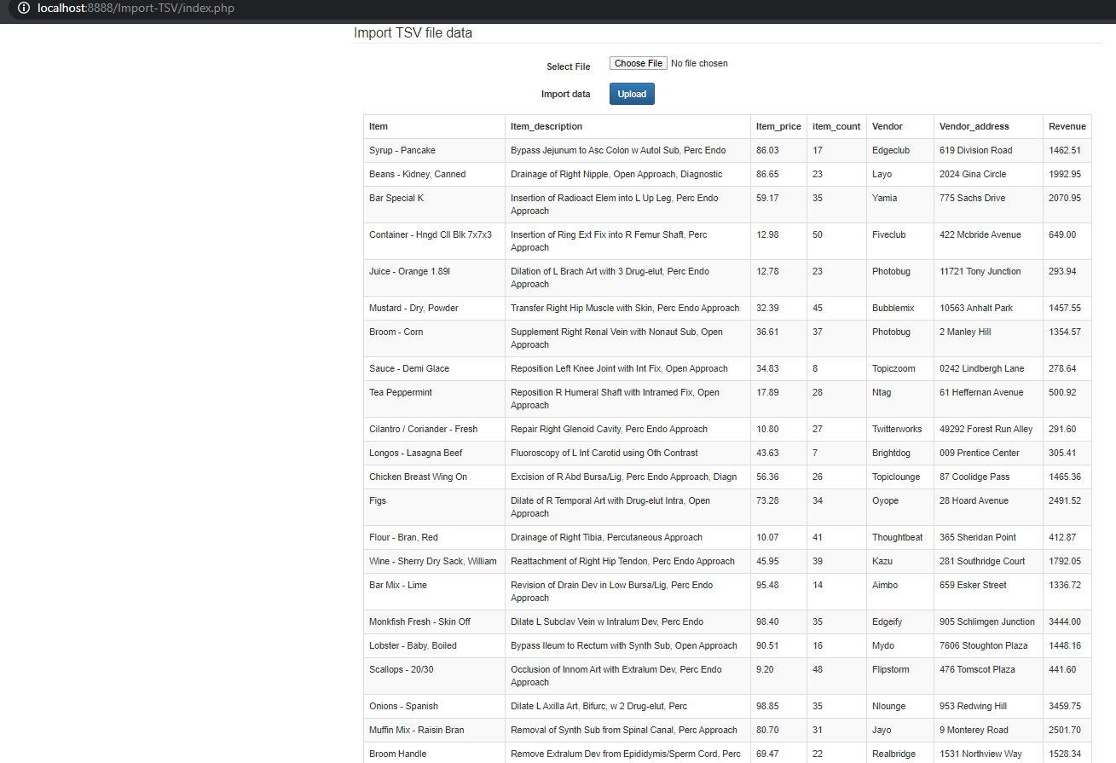

* Scroll to the bottom and you should see the Total Revenue which is $114802.93.Screenshot below.

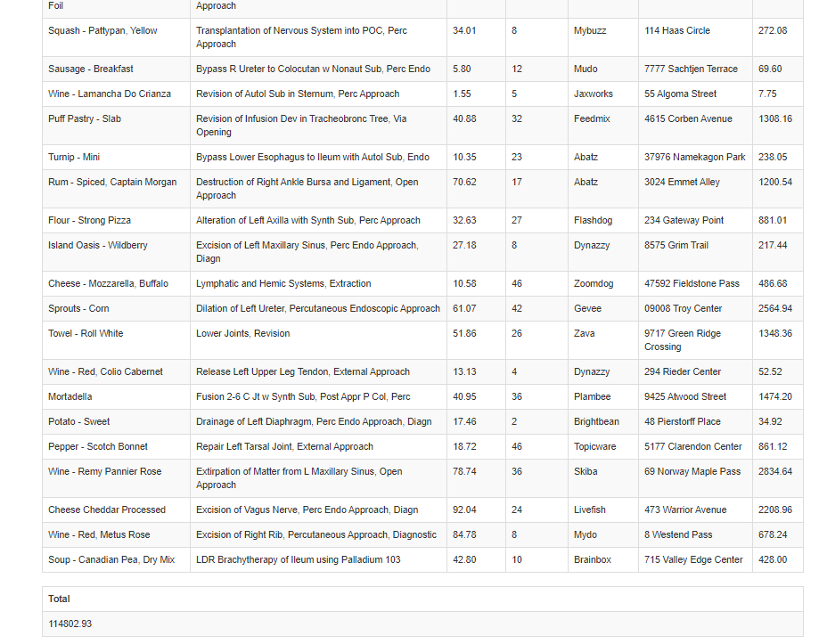

## Conclusion.

The web application should display all the information as per the requirement except the Page Navigation option. Test Results and some of the important code snapshots explaining the code are included in the ‘Test Results’ document.